Arduino: Endless Clicker Game

Grade 11 Computer Engineering

Caleb Lam

2019

# Table of Contents

About This Project 3

Materials and Software 4

Schematic Diagram 5

Assembly Diagram 6

Building the Circuit 7

Processing Sketch 11

Arduino Sketch 21

Photos 29

Learn More 30

# About This Project

This project allows you to learn about serial communication with other software.

In Processing, a game is made. There are 3 lanes, each with a button at the end. There will be circles moving on one of these lanes towards the right of the screen. When a circle starts to overlap with one of the buttons, clicking on that button will make the circle disappear and a point will be earned. If a circle moves to the far right of the screen, one chance will be lost. You will have 3 chances only.

The Arduino will communicate with Processing to receive data so it can display the score using a 4-in-1 MAX7219 LED matrix display, the number of chances left using 3 LEDs and emit sound with a buzzer when needed.

# Materials and Software

The following materials are needed:

* 1× Arduino board*
* 1× USB cable (Type A to B)
* 1× Breadboard
* 1× 4-in-1 MAX7219 LED matrices (8×8)
* 1× Piezo buzzer
* Resistors
  + 1× 10kΩ
  + 1× 1.3kΩ
  + 3× 680Ω
  + 1× 5.1kΩ
* LEDs
  + 3× Red
  + 1× Green
* 5× Female-to-female jump wires
* Wires

*Do **NOT** use clones. Use only the **genuine** Arduino boards.

The following software are required on your computer:

* Arduino IDE: <https://www.arduino.cc/en/main/software>

This will be used to program the Arduino board to control the LEDs, buzzer, and score board.

* Processing: <https://processing.org/download/>

This will be used to program the logic (and visuals) of the game.

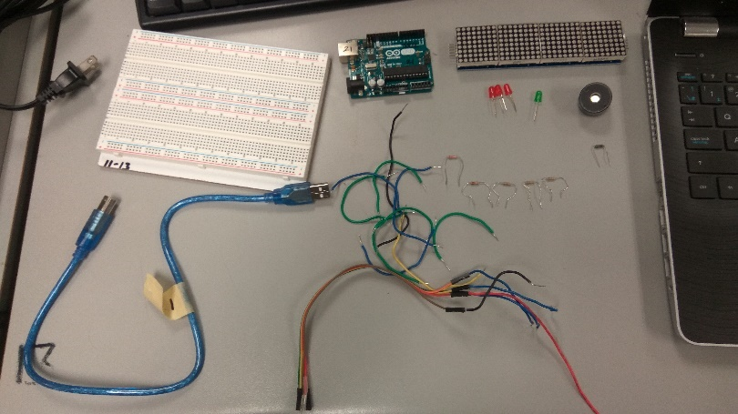

# Schematic Diagram

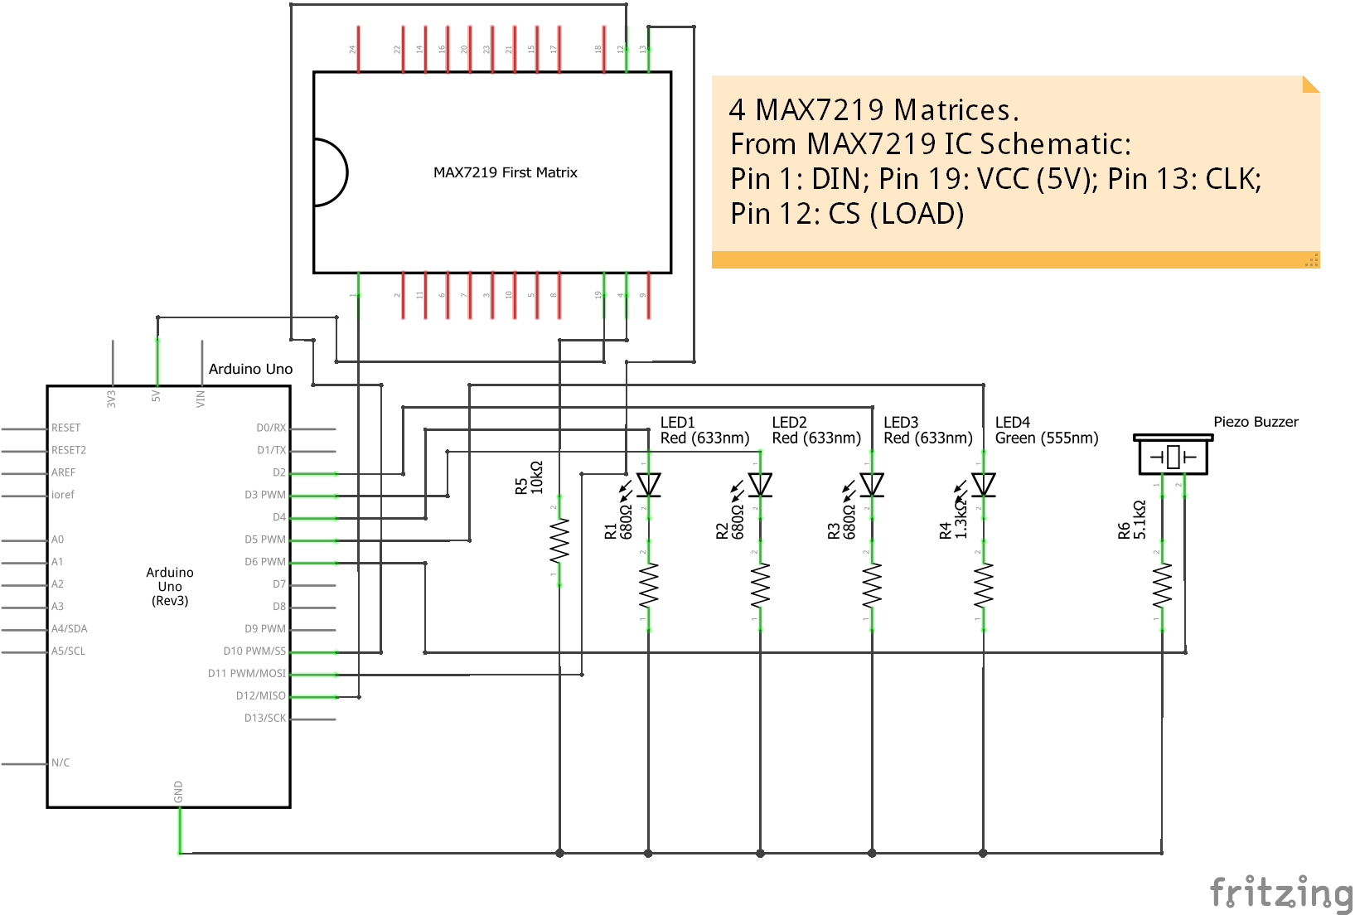

# Assembly Diagram

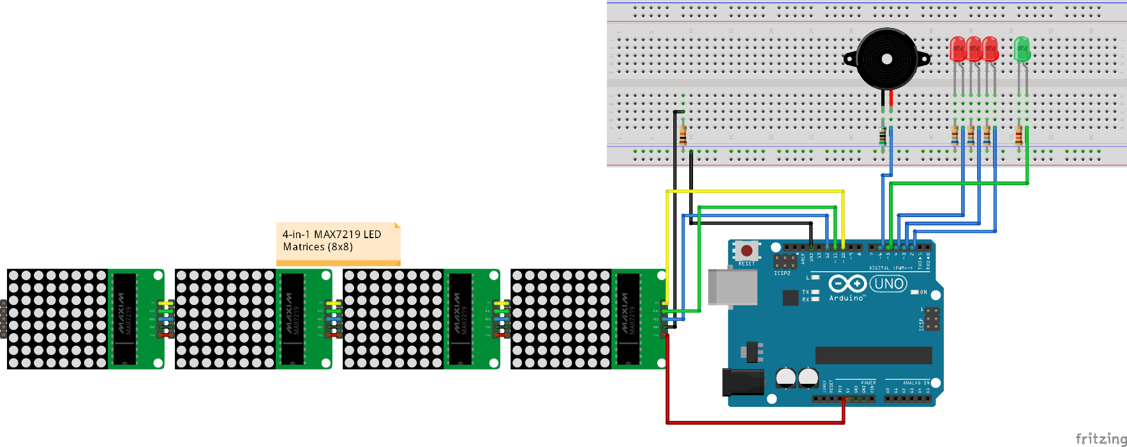

# Building the Circuit

1. On one end of the female-to-female jump wires, plug a wire into each end. On the other end, connect the jumper wires to the pins of the 4-in-1 LED matrix on the side that has the DIN pin.

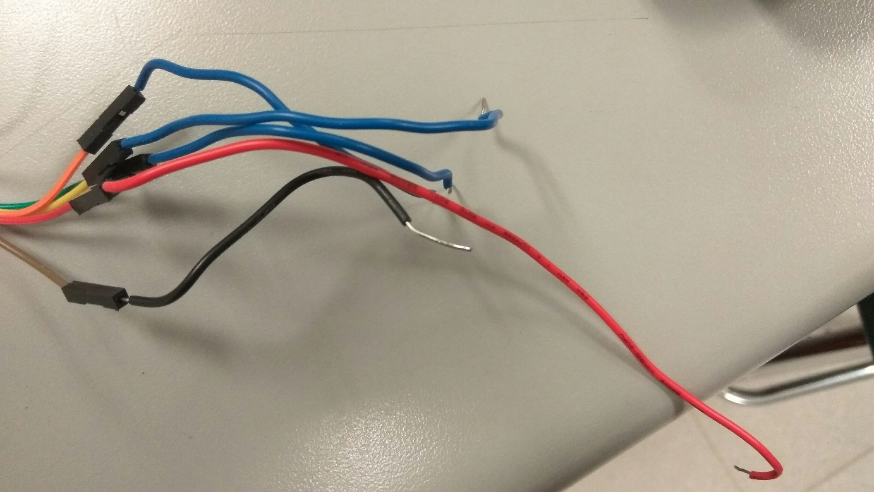  
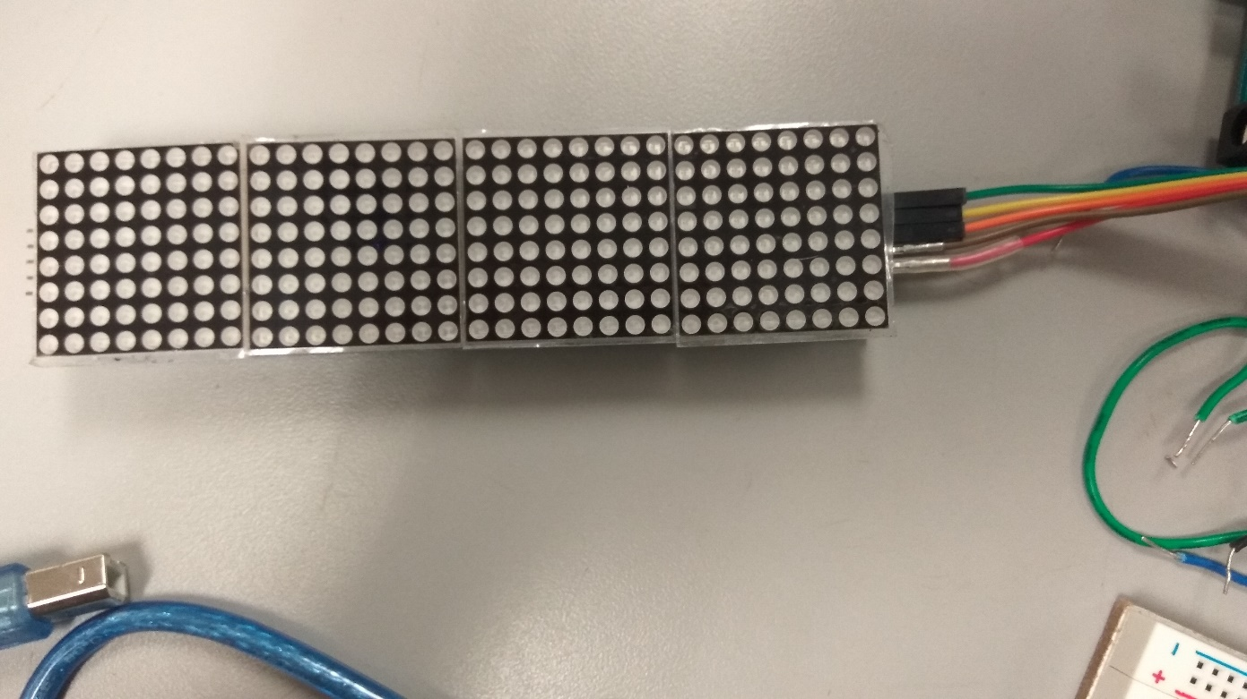

1. Connect the wire that is plugged in to the GND pin of the matrices to one of the holes of the mid-bottom sections of the breadboard. Connect a 10kΩ resistor from that wire to the minus (-) line. Connect the minus line to the GND pin of the Arduino board.  
   Then, connect the wire that is plugged in to the VCC pin to the 5V pin on the bottom of the Arduino board, and the ones plugged in to the DIN, CLK and CS pins of the matrices to pins 12, 11 and 10 separately.  
   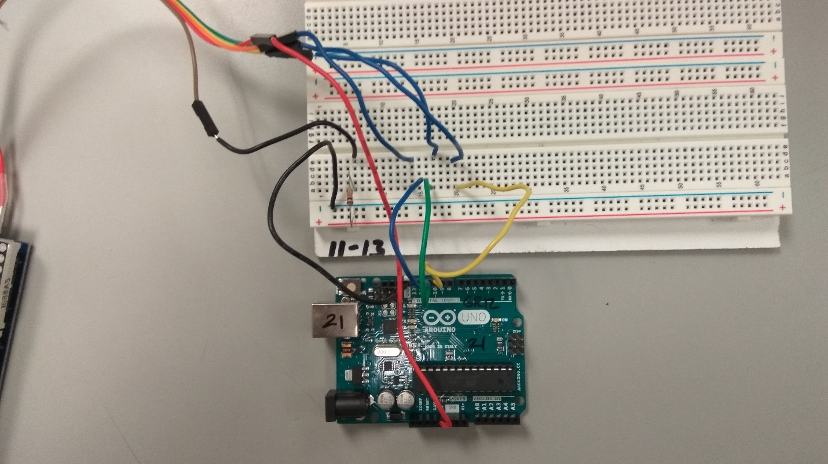
2. Set up the piezo buzzer. Connect a 5.1kΩ resistor from the minus line to the cathode (-) of the buzzer and a wire from its anode (+) to pin 6 of the Arduino board.  
   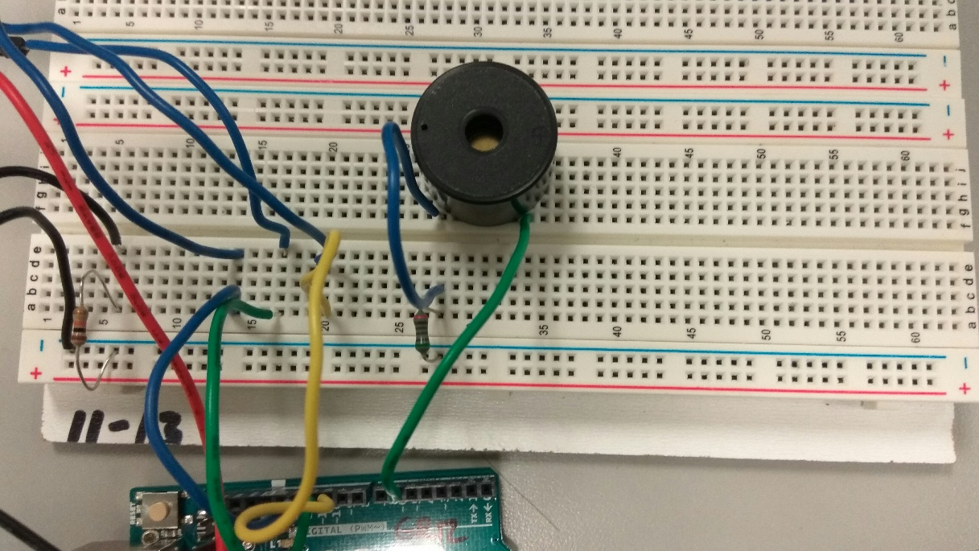
3. Set up the LEDs. For each of the red ones, connect one 680Ω resistor from the minus line to the cathode of the LED and a wire from its anode to pin 4 of the Arduino board. Do the same to the other two that connect to pins 3 and 2.  
   For the green one, connect one 1.3kΩ resistor from the minus line to the cathode of the LED and a wire from its anode to pin 4 of the Arduino board.  
   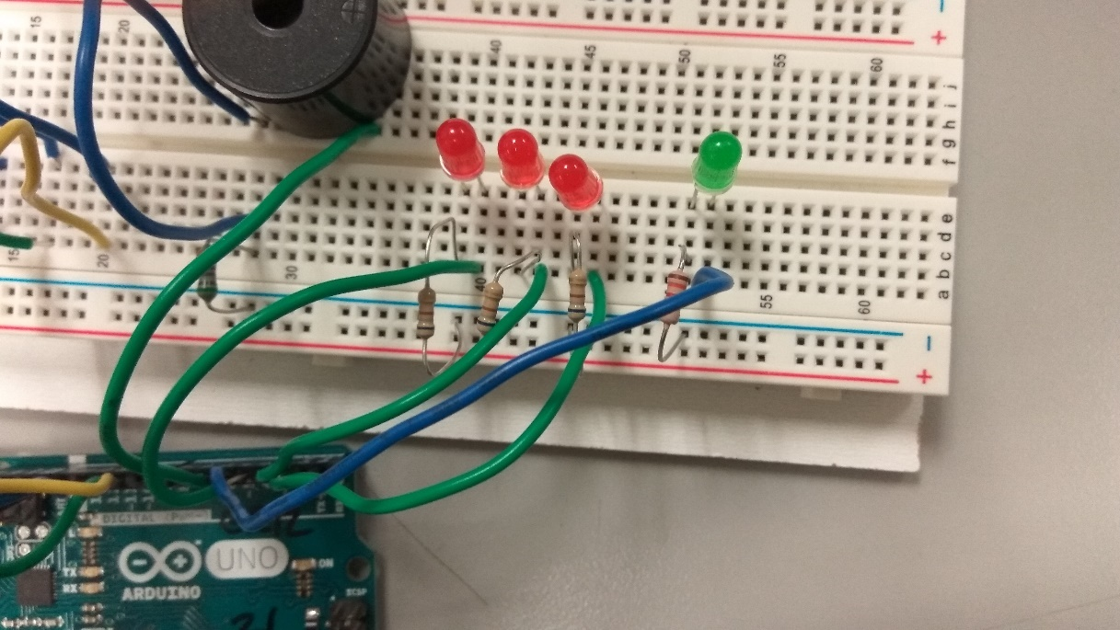

Your whole circuit should now look like this.

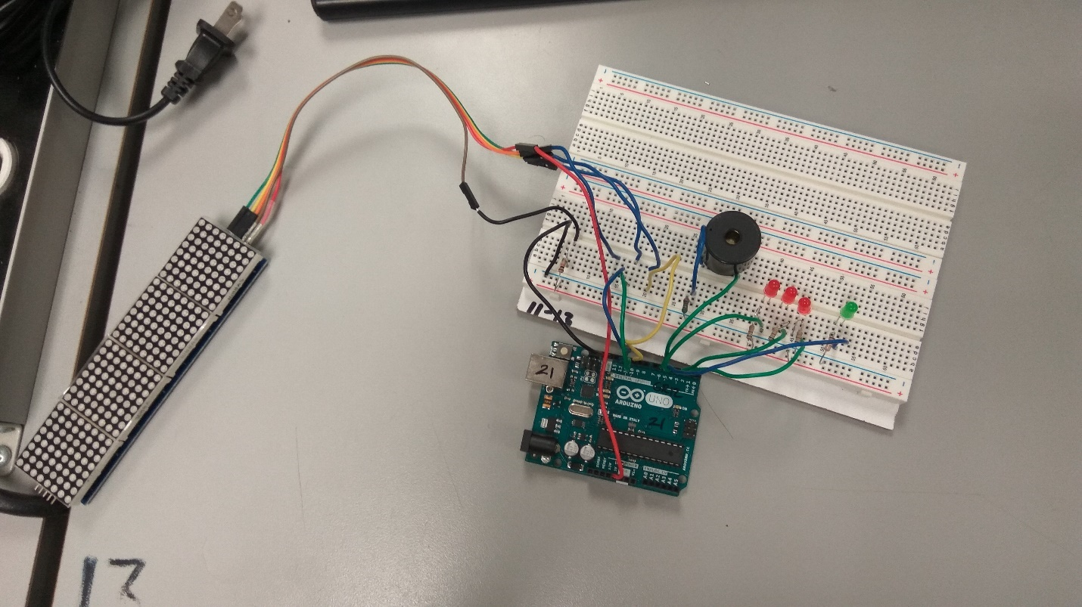

Plug in the USB cable, then continue onto the programming part.

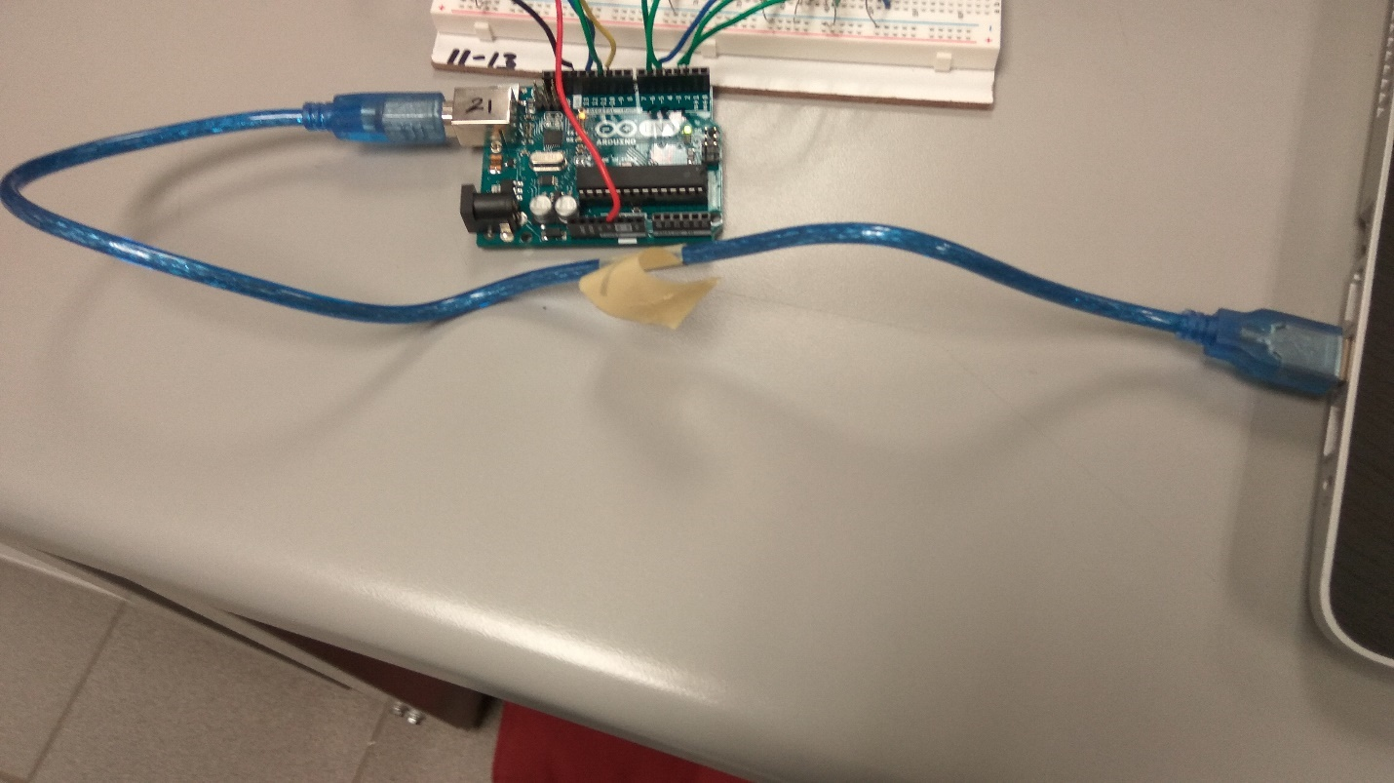

# Processing Sketch

Open up Processing by double-clicking on the shortcut. This will create a new (unsaved) sketch (project).

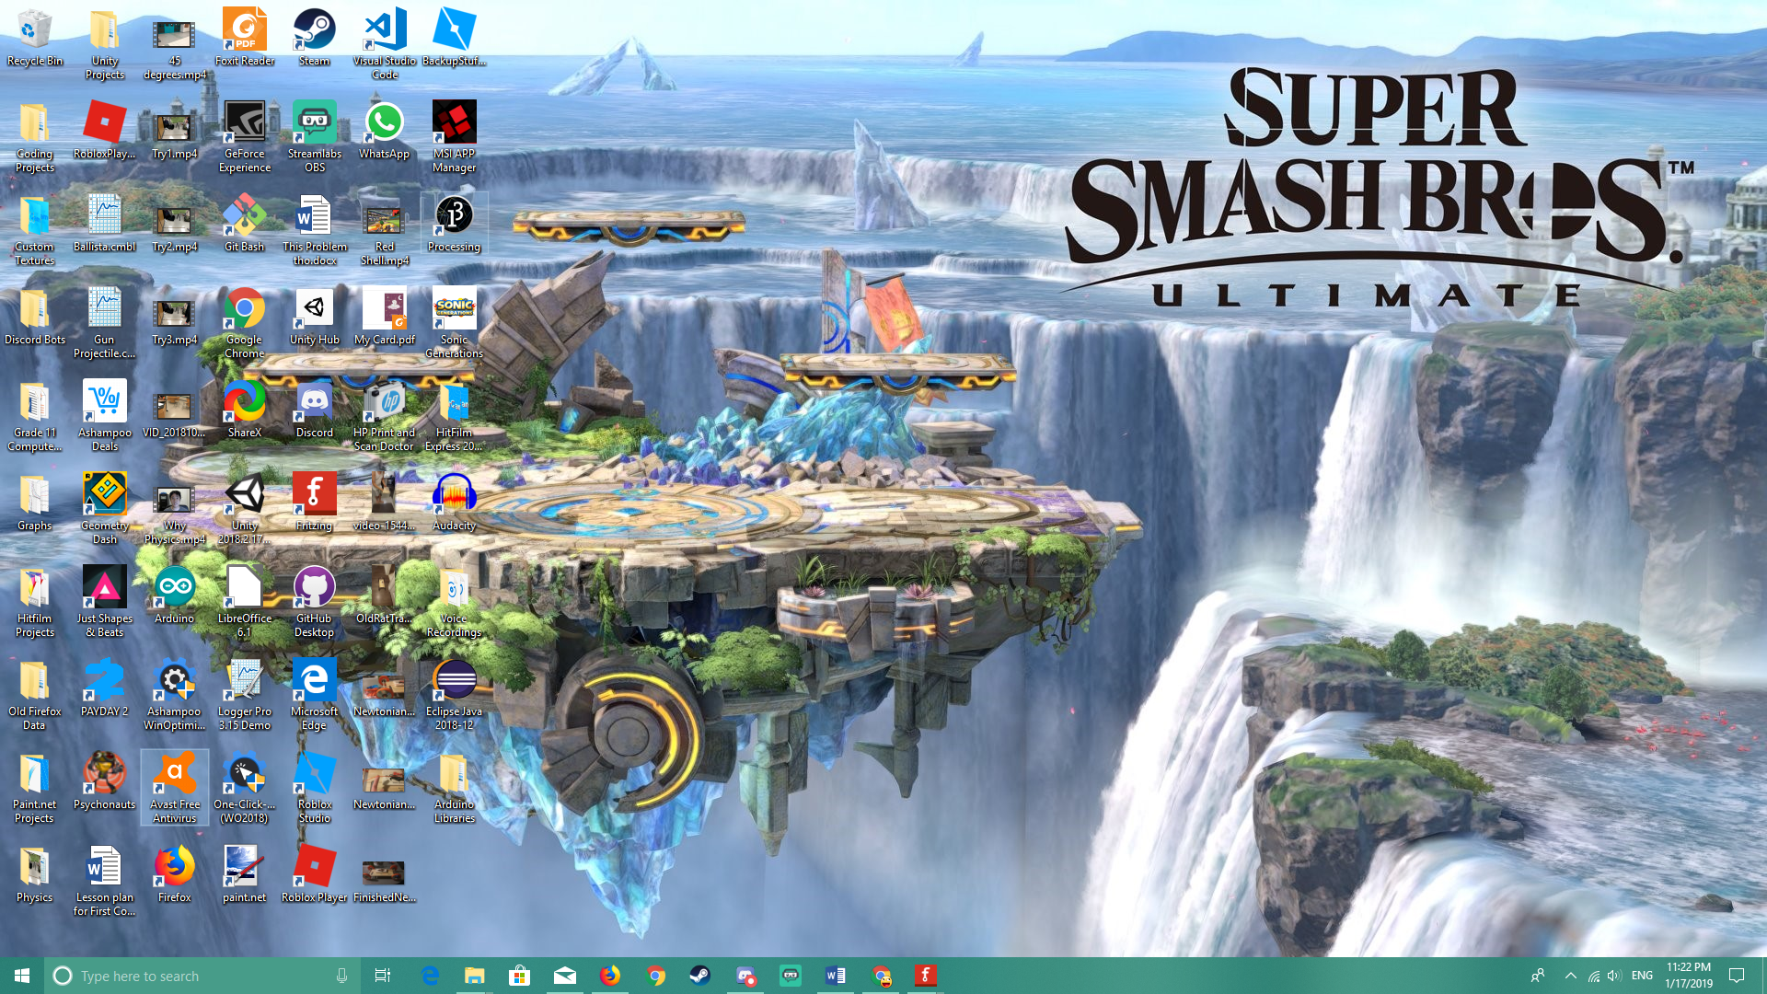

Write this code in your sketch.

1. // Libraries //
2. **import** java.util.concurrent.*; // To get access to the CopyOnWriteArrayList object.
3. **import** processing.serial.*; // To get access to the Serial functions.
5. // Fonts //
6. String fontsFolder = "fonts/";
7. PFont boldFont; // Bolded font
8. PFont thinFont; // Normal text font
10. // Serial Communication Variables //
11. String DATA_STRING = "0"; // The data to send.
12. **int** PORT_INDEX = 0; // This should be 1 if on a desktop. Change it to suit your device.
13. Serial port = **null**; // To store the connected serial port.
14. **boolean** gameReady = **false**; // Is true when a serial port is connected.
15. **boolean** GAME_DEBUG = **false**; // Skip the serial connection. Debugging purposes only.
17. // Game Control Variables //
18. **int** scene = 0; // To control the scene that is rendered in the game. Different scenes have different functions.
20. // Keep track of time to spawn circles or increase difficulty when needed.
21. **int** lastSpawnMillis = 0;
22. **int** lastDiffMillis = 0;
24. **int** maxCircles = 20; // For each lane, check if the number of circles is smaller or equal to this number.
25. CopyOnWriteArrayList<CopyOnWriteArrayList<Circle>> circles = **new** CopyOnWriteArrayList<CopyOnWriteArrayList<Circle>>(); // Stores the list of circles.
27. **float** diffIncreaseTime = 30f; // Increase the difficulty after this many seconds.
29. **float** spawnTime = 3f; // Spawn a circle after this many seconds.
30. **float** minSpawnTime = 0.7f; // Caps the minimum time before a circle is spawned.
31. **float** maxSpawnTime = 3f; // Caps the maximum time before a circle is spawned.
33. **float** circleShiftRate = 2f; // Move all circles by this many pixels.
34. **float** minShiftRate = 2f; // Caps the minimum shift rate before a circle is spawned.
35. **float** maxShiftRate = 4f; // Caps the maximum shift rate before a circle is spawned.
37. **int** points = 0; // The score.
38. **int** chances = 3; // The number of chances left.
39. **int** maxChances = 3; // The number of chances you get at maximum.
41. **int** highScore = 0; // The high score.
43. // Title Screen Variables //
44. // Title Text
45. String title = "Endless Clicker"; // The title of this game.
46. color titleColor = color(125, 25, 125); // Title color in RGB. Google "RGB color picker" to pick the right colors.
47. **float** titleTrans = 10f; // Transparency.
48. **float** titleTransMin = 20f; // Minimum transparency.
49. **float** titleTransMax = 255f; // Maximum transparency.
50. **float** titleTransChangeRate = 255f/120f; // Increase/decrease transparency by this much every frame.
52. // Play Button Variables
53. color playButtonColor = color(130, 255, 70); // Button's background color.
54. color playButtonHoverColor = color(0, 125, 0); // Button's background color when the mouse is over it.
55. color playButtonTextColor = color(0, 125, 0); // Button's text color.
56. color playButtonTextHoverColor = color(130, 255, 70); // Button's text color when the mouse is over it.
57. **float** playButtonWidth = 100f; // Button's width.
58. **float** playButtonHeight = 50f; // Button's height.
60. // Game Screen Variables //
61. // Lanes
62. **float** laneWidth = 600f; // A lane's width.
63. **float** laneHeight = 80f; // A lane's height.
65. color laneColors[] = { // Colors of each lane.
66. color(255, 40, 45),
67. color(255, 255, 120),
68. color(120, 255, 160)
69. };
71. PVector lanePositions[] = **new** PVector[3]; // Positions of each lane.
73. // Game Buttons
74. **float** buttonSize = laneHeight; // Size of each lane button.
75. color buttonColors[] = { // Colors of each lane button.
76. color(255, 0, 45),
77. color(255, 255, 0),
78. color(0, 255, 76)
79. };
80. color buttonHoverColors[] = { // Colors of each lane button when the mouse is over it.
81. color(180, 0, 30),
82. color(180, 180, 0),
83. color(0, 180, 50)
84. };
86. // Circles
87. color circleFaceColor = color(200, 200, 200); // Front color of the circle.
88. color circleBackColor = color(255, 255, 255); // Color of the circle's edge.
89. **float** circleSize = laneHeight; // The circle's diameter is the same has a lane's height.
90. **float** faceToBackSizeRatio = 0.8f; // 20% of the circle's area is the edge.
92. // Game Over Screen //
93. // Game Over Text
94. String gameOverText = "Game Over"; // Text to display when the game is over.
95. color gameOverTextColor = color(255, 0, 0); // Color of the game over text.
97. // Play Again Button
98. // Similar to the Play button's variables.
99. color playAgainButtonColor = color(130, 255, 70);
100. color playAgainButtonHoverColor = color(0, 125, 0);
101. color playAgainButtonTextColor = color(0, 125, 0);
102. color playAgainButtonTextHoverColor = color(130, 255, 70);
103. **float** playAgainButtonWidth = 200f;
104. **float** playAgainButtonHeight = 50f;
106. // Main Menu Button
107. // Similar to the Play button's variables.
108. color mainMenuButtonColor = color(255, 0, 45);
109. color mainMenuButtonHoverColor = color(180, 0, 30);
110. color mainMenuButtonTextColor = color(255, 255, 0);
111. color mainMenuButtonTextHoverColor = color(255, 255, 0);
112. **float** mainMenuButtonWidth = 200f;
113. **float** mainMenuButtonHeight = 50f;
115. // Menus Buttons //
116. Button playButton; // Click on it to play.
117. Button laneButtons[] = **new** Button[3]; // Stores the lane buttons.
118. Button playAgainButton; // Click on it to play again.
119. Button mainMenuButton; // Click on it to return to the main menu.
121. // The button class to create buttons.
122. **class** Button {
123. **public** String label;
124. **public** PFont font;
125. **public** **float** x;    // top left corner x position
126. **public** **float** y;    // top left corner y position
127. **public** **float** w;    // width of button
128. **public** **float** h;    // height of button
129. **public** **float** r;    // radius for round corners
130. **public** color fillColor;
131. **public** color strokeColor;
132. **public** color textColor;
133. **public** color textStrokeColor;
135. // Constructor with text.
136. Button(String labelB, PFont fontB, **float** xpos, **float** ypos, **float** widthB, **float** heightB, **float** radiusB, color fillColorB, color textColorB) {
137. **this**.label = labelB;
138. **this**.font = fontB;
139. **this**.x = xpos;
140. **this**.y = ypos;
141. **this**.w = widthB;
142. **this**.h = heightB;
143. **this**.r = radiusB;
144. **this**.fillColor = fillColorB;
145. **this**.textColor = textColorB;
146. }
148. // Constructor without text.
149. Button(**float** xpos, **float** ypos, **float** widthB, **float** heightB, **float** radiusB, color fillColorB) {
150. **this**.label = "";
151. **this**.font = thinFont;
152. **this**.x = xpos;
153. **this**.y = ypos;
154. **this**.w = widthB;
155. **this**.h = heightB;
156. **this**.r = radiusB;
157. **this**.fillColor = fillColorB;
158. }
160. // Displays the button.
161. **void** Draw() {
162. fill(**this**.fillColor);
163. textFont(**this**.font);
164. // stroke(this.strokeColor);
165. noStroke();
166. rectMode(CENTER);
167. rect(**this**.x, **this**.y, **this**.w, **this**.h, **this**.r);
168. textAlign(CENTER, CENTER);
170. **if** (!**this**.label.equals("")) {
171. fill(**this**.textColor);
172. stroke(**this**.textStrokeColor);
173. text(**this**.label, **this**.x, **this**.y);
174. }
175. }
177. // Checks if the mouse is over the button.
178. **boolean** MouseIsOver() {
179. **return** (mouseX >= (**this**.x - **this**.w/2) && mouseX <= (**this**.x + **this**.w/2) && mouseY >= (**this**.y - **this**.h/2) && mouseY <= (**this**.y + **this**.h/2));
180. }
181. }
183. // The circle class to create circles.
184. **class** Circle {
185. **public** **int** lane; // Which lane the circle runs on.
186. **public** **float** x; // The horizontal position.
187. **public** color faceColor; // Front color.
188. **public** color backColor; // Back/edge color.
190. **private** **float** diameter = (**float**) laneHeight; // Diameter.
192. // Constructor.
193. Circle (**int** laneB, color faceColorB, color backColorB) {
194. **this**.lane = laneB;
195. **this**.faceColor = faceColorB;
196. **this**.backColor = backColorB;
198. diameter = laneHeight;
199. **this**.x = lanePositions[laneB].x - laneWidth/2 + diameter/2;
200. }
202. // Increases x by the shift rate.
203. **void** ShiftPosition () {
204. **this**.x += circleShiftRate;
205. }
207. // Display the circle.
208. **void** Draw () {
209. ellipseMode(CENTER);
210. fill(backColor);
211. ellipse(**this**.x, 120 + (lane * 80), diameter, diameter);
212. fill(faceColor);
213. ellipse(**this**.x, 120 + (lane * 80), diameter * faceToBackSizeRatio, diameter * faceToBackSizeRatio);
214. }
215. }
217. // Always runs first.
218. **void** setup () {
219. // Set up canvas and initial settings.
220. size(800, 400);
221. rectMode(CENTER);
222. noStroke();
224. // Create fonts.
225. boldFont = createFont(fontsFolder + "Roboto-Bold.ttf", 40);
226. thinFont = createFont(fontsFolder + "Roboto-Thin.ttf", 25);
228. // Store the lane width and height.
229. laneWidth = width * 0.75f;
230. laneHeight = height * 0.2f;
232. // Store the list of circles for each lane and the positions of each lane and its button.
233. **for** (**int** i = 0; i < lanePositions.length; i++) {
234. lanePositions[i] = **new** PVector(width/2 - buttonSize, 120 + i * 80);
235. laneButtons[i] = **new** Button(lanePositions[i].x + laneWidth/2 + buttonSize/2, lanePositions[i].y, buttonSize, buttonSize, 0f, buttonColors[i]);
236. circles.add(**new** CopyOnWriteArrayList<Circle>());
237. }
239. // Set up menu buttons.
240. playButton = **new** Button("Play", thinFont, (**float**) width/2, (**float**) height/2 + 120, playButtonWidth, playButtonHeight, 0f, playButtonColor, playButtonTextColor);
241. playAgainButton = **new** Button("Play Again", thinFont, (**float**) width/2, (**float**) height/2 + 60, playAgainButtonWidth, playAgainButtonHeight, 0f, playAgainButtonColor, playAgainButtonTextColor);
242. mainMenuButton = **new** Button("Main Menu", thinFont, (**float**) width/2, (**float**) height/2 + 120, mainMenuButtonWidth, mainMenuButtonHeight, 0f, mainMenuButtonColor, mainMenuButtonTextColor);
244. // Connect to the serial port and begin drawing the scene.
245. updatePort();
246. updateScreen();
247. }
249. // Runs countless times.
250. **void** draw () {
251. updateScreen(); // Draw the scene.
253. // Send data to the serial port. (Character by character)
254. DATA_STRING = "|" + Integer.toString(scene) + "," + Integer.toString(chances) + "," + String.format("%04d", points) + "," + String.format("%04d", highScore) + "\n";
255. **if** (port != **null** && !GAME_DEBUG) {
256. println(DATA_STRING);
257. //port.write(DATA_STRING);
258. **for** (**int** i = 0; i < DATA_STRING.length(); i++) {
259. port.write(DATA_STRING.charAt(i));
260. }
261. }
262. }
264. // Runs when the mouse is clicked.
265. **void** mouseClicked () {
266. **switch** (scene) {
267. **case** 0 :
268. **if** (playButton.MouseIsOver() && (gameReady || GAME_DEBUG)) {
269. // Start the game.
270. points = 0;
271. scene = 1;
272. }
273. **break**;
274. **case** 1 :
275. // Check if a lane button is pressed and a circle overlaps it. Remove the circle if it does.
276. // This will give you a point.
277. **for** (**int** i = 0; i < laneButtons.length; i++) {
278. Button laneButton = laneButtons[i];
279. **if** (laneButton.MouseIsOver()) {
280. CopyOnWriteArrayList<Circle> laneCircles = circles.get(i);
281. **for** (Circle circle : laneCircles) {
282. **if** (circle != **null**) {
283. **if** (circle.x >= laneButton.x - buttonSize) {
284. circles.get(i).remove(laneCircles.indexOf(circle));
285. // Earn a point!
286. points++;
287. println("Points: " + points);
288. **break**;
289. }
291. }
292. }
293. }
294. }
295. **break**;
296. **case** 2:
297. // Play the game again. (Reset and switch back to scene 1.)
298. **if** (playAgainButton.MouseIsOver()) {
299. resetGame();
300. scene = 1;
301. }
303. // Go back to the main menu. (Reset and switch back to scene 0.)
304. **if** (mainMenuButton.MouseIsOver()) {
305. resetGame();
306. scene = 0;
307. }
308. **break**;
309. }
310. }
312. // The main function that draws the scenes.
313. **void** updateScreen () {
314. **switch** (scene) {
315. **case** 0 : // Title screen/Main menu
316. // Title Background
317. background(125, 125, 125);
319. // Title Text
320. fill(titleColor, titleTrans);
321. titleTrans += titleTransChangeRate;
322. **if** (titleTrans >= titleTransMax) {
323. titleTransChangeRate = -255f/120f;
324. }
325. **else** **if** (titleTrans <= titleTransMin) {
326. titleTransChangeRate = 255/120f;
327. }
328. textFont(boldFont);
329. rectMode(CENTER);
330. textAlign(CENTER);
331. // textMode(SHAPE);
332. text(title, width/2, height/3 - 80);
334. // Controls Text
335. textFont(thinFont);
336. fill(255, 255, 255);
337. text("Click on a square button when a circle starts to overlap it.", width/2, height/3 - 30);
338. fill(0, 255, 0);
339. text("Each successful click is worth 1 point.", width/2, height/3 + 10);
340. fill(255, 0, 0);
341. text("You can only miss 3 circles.", width/2, height/3 + 50);
342. fill(0, 255, 255);
343. text("Good luck!", width/2, height/3 + 90);
345. // Checks for Arduino.
346. **if** (port == **null** && !GAME_DEBUG) {
347. fill(255, 0, 0);
348. textFont(thinFont);
349. text("Waiting for Arduino...", playButton.x, playButton.y);
350. updatePort(); // Reconnect if no Arduino is detected.
351. }
352. **else** {
353. // Make the Play button available.
354. **if** (playButton.MouseIsOver()) {
355. playButton.fillColor = playButtonHoverColor;
356. playButton.textColor = playButtonTextHoverColor;
357. }
358. **else** {
359. playButton.fillColor = playButtonColor;
360. playButton.textColor = playButtonTextColor;
361. }
362. playButton.Draw();
363. }
364. **break**;
365. **case** 1: // Game screen
366. background(125, 125, 125);
367. rectMode(CENTER);
369. drawLanesAndButtons(); // Draw the lanes and buttons.
370. removeOrShiftCircles(); // Remove the missed circles and/or move existing ones.
372. // Spawn a circle if the timing is right.
373. **int** mil = millis();
374. **int** deltaTimeSpawn = mil - lastSpawnMillis;
375. **int** deltaTimeDiff = mil - lastDiffMillis;
376. **if** (deltaTimeSpawn >= spawnTime * 1000  || lastSpawnMillis <= 0) {
377. lastSpawnMillis = mil;
378. spawnCircle();
379. }
381. // Increase the difficulty if the timing is right.
382. **if** (deltaTimeDiff >= diffIncreaseTime * 1000) {
383. lastDiffMillis = mil;
384. increaseDifficulty();
385. }
386. **break**;
387. **case** 2: // Game over screen.
388. background(125, 125, 125);
389. fill(gameOverTextColor);
391. textFont(boldFont);
392. rectMode(CENTER);
393. textAlign(CENTER);
395. // Game over text.
396. text(gameOverText, width/2, height/3);
398. // Set a new high score if there is one.
399. **if** (points > highScore) {
400. highScore = points;
401. }
403. // Draw the Play Again button.
404. **if** (playAgainButton.MouseIsOver()) {
405. playAgainButton.fillColor = playAgainButtonHoverColor;
406. playAgainButton.textColor = playAgainButtonTextHoverColor;
407. }
408. **else** {
409. playAgainButton.fillColor = playAgainButtonColor;
410. playAgainButton.textColor = playAgainButtonTextColor;
411. }
412. playAgainButton.Draw();
414. // Draw the Main Menu button.
415. **if** (mainMenuButton.MouseIsOver()) {
416. mainMenuButton.fillColor = mainMenuButtonHoverColor;
417. mainMenuButton.textColor = mainMenuButtonTextHoverColor;
418. }
419. **else** {
420. mainMenuButton.fillColor = mainMenuButtonColor;
421. mainMenuButton.textColor = mainMenuButtonTextColor;
422. }
423. mainMenuButton.Draw();
425. **break**;
426. }
427. }
429. // Connects to a serial port.
430. **boolean** connect(**int** portNumber, **int** baudRate, **int** limit){
431. **int** tries = 0;
432. **while**(tries < limit) {
433. **try** {
434. port = **new** Serial(**this**, Serial.list()[portNumber], baudRate);
435. port.clear();
436. }
437. **catch** (Exception e) {
438. System.err.println("Retrying");
439. tries++;
440. **continue**;
441. }
442. **break**;
443. }
444. **if** (tries < limit) {
445. println("Successful in " + str(tries + 1) + " tries.");
446. **return** **true**;
447. }
448. **else** {
449. System.err.println("Unsucessful. Reached limit.");
450. **return** **false**;
451. }
452. }
454. // Updates the port variable.
455. **void** updatePort() {
456. String portList[] = Serial.list();
457. **if** (portList.length > 0 && port == **null**) {
458. println("Connecting to serial " + portList[0]);
459. gameReady = connect(PORT_INDEX, 9600, 10); // The first parameter should be 1 if you are using a desktop.
460. }
461. **else** {
462. port = **null**;
463. }
464. }
466. // Draws the lanes and their buttons.
467. **void** drawLanesAndButtons () {
468. **for** (**int** i = 0; i < lanePositions.length; i++) {
469. **float** x = lanePositions[i].x;
470. **float** y = lanePositions[i].y;
471. color laneColor = laneColors[i];
472. Button laneButton = laneButtons[i];
474. noStroke();
475. rectMode(CENTER);
476. fill(laneColor);
477. rect(x, y, laneWidth, laneHeight);
479. **if** (laneButton.MouseIsOver()) {
480. laneButton.fillColor = buttonHoverColors[i];
481. }
482. **else** {
483. laneButton.fillColor = buttonColors[i];
484. }
485. laneButton.Draw();
487. }
488. }
490. // Removes missed circle or draw existing ones.
491. **void** removeOrShiftCircles () {
492. **for** (**int** i = 0; i < lanePositions.length; i++) {
493. CopyOnWriteArrayList<Circle> laneCircles = circles.get(i);
494. Button laneButton = laneButtons[i];
495. **for** (Circle circle : laneCircles) {
496. // If a circle passes through its lane's button.
497. **if** (circle.x > laneButton.x + buttonSize) {
498. circles.get(i).remove(0); // Remove it.
499. // Lose a chance.
500. chances--;
502. // If no chances are left, it is a "Game Over!"
503. **if** (chances == 0) {
504. scene = 2;
505. }
506. }
507. **else** {
508. // If the circle is still behind the button, shift it.
509. circle.ShiftPosition();
510. circle.Draw();
511. }
512. }
513. }
514. }
516. // Spawns a circle.
517. **void** spawnCircle () {
518. **int** lane = floor(random(lanePositions.length));
519. **if** (circles.get(lane).size() < maxCircles) { // Makes sure the lane is not overloaded.
520. Circle circle = **new** Circle(lane, circleFaceColor, circleBackColor);
521. circles.get(lane).add(circle);
522. circle.Draw();
523. }
524. }
526. // Increases the difficulty. (Circles spawn more and go faster.)
527. **void** increaseDifficulty() {
528. spawnTime = max(spawnTime - 0.5f, minSpawnTime);
529. circleShiftRate = min(circleShiftRate + 0.2f, maxShiftRate);
530. }
532. // Resets the game. Empties the circles list and sets the game variables back to their initial values.
533. **void** resetGame () {
534. circles = **new** CopyOnWriteArrayList<CopyOnWriteArrayList<Circle>>();
535. **for** (**int** i = 0; i < lanePositions.length; i++) {
536. circles.add(**new** CopyOnWriteArrayList<Circle>());
537. }
538. points = 0;
539. chances = maxChances;
540. circleShiftRate = minShiftRate;
541. spawnTime = maxSpawnTime;
542. lastSpawnMillis = 0;
543. lastDiffMillis = 0;
544. }

Make sure you **save** the sketch afterwards. (Use Ctrl + S for Windows users or Command + S for Mac users.) Save it anywhere as a name you make up. Do **NOT** close the Processing sketch window just yet!

# Arduino Sketch

Open up the Arduino IDE by double-clicking on the shortcut. This will open up a new Arduino sketch.

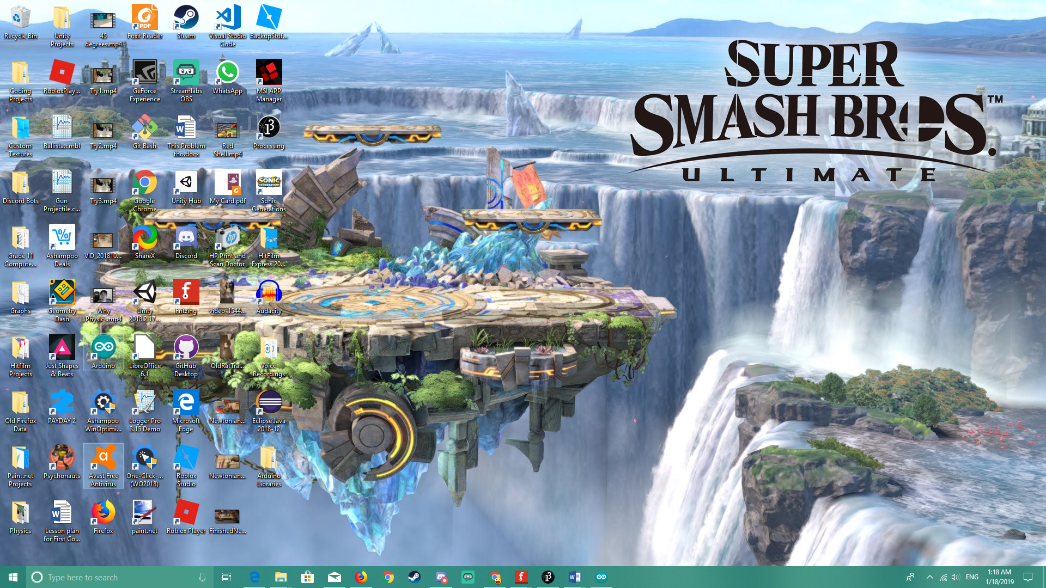

Ensure that the **Port** is not empty (in the Tools menu) and the Board and Processor is set to the correct type (which depends on what you are using).

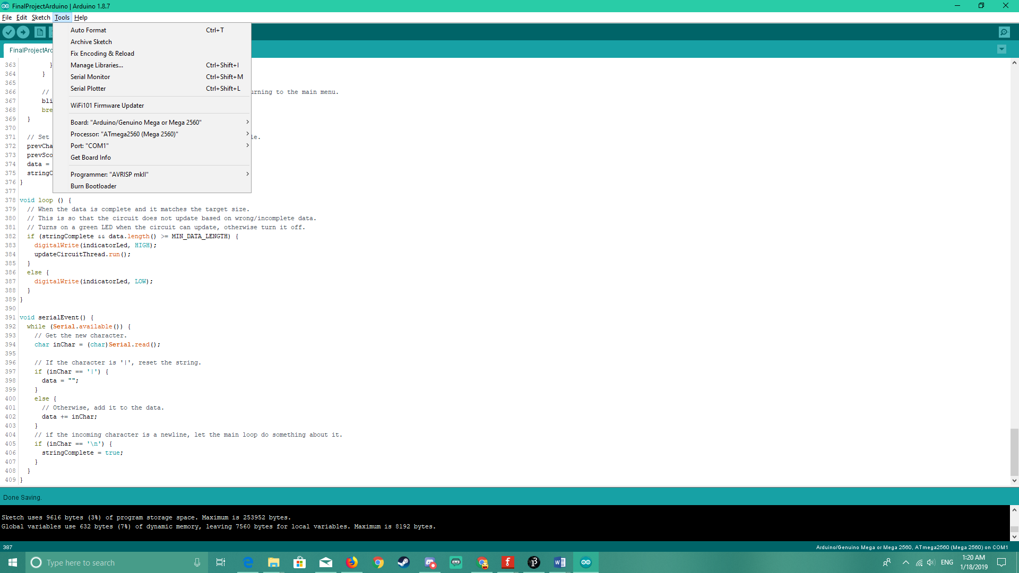

**This should be something other than COM1 when you plug in an Arduino board.**

Write this code in your sketch.

1. // Libraries //
2. // Include some functions to control some components.
3. #include <Thread.h>
4. #include <LedControl.h>
6. // Note Frequencies //
7. // Define the frequencies of each (used) note.
8. #define NOTE_LOW_B 247
9. #define NOTE_C 523
10. #define NOTE_D 587
11. #define NOTE_E 659
12. #define NOTE_G 784
13. // Matrix Pins
14. #define DIN 12
15. #define CLK 11
16. #define CS 10
18. // Serial Data Variables //
19. // Stores data received from the serial.
20. String data = String(""); // Initialize it. (Just "" does not do that.)
21. **int** MIN_DATA_LENGTH = 13; // Max langth to run functions based on the data.
22. **bool** stringComplete = **false**; // Whether the string is ready to be processed.
24. // Pins and Component Variables //
25. **int** buzzerPin = 6; // Buzzer.
26. **int** numModules = 4; // There are this many modules.
27. **int** moduleSize = 8; // The number of LEDs for each row and column.
29. // LED Pins
30. **int** ledPins[] = {4, 3, 2}; // Red LEDs.
31. **int** indicatorLed = 5; // Green LED.
33. // LedControl object to control the matrices.
34. LedControl lc = LedControl(DIN, CLK, CS, numModules);
36. // Variables that store data extracted from the serial data.
37. **int** scene;
38. **int** chances;
39. String score; // Already padded with zeroes.
40. String highScore;
41. **int** prevChances = 3;
42. String prevScore = "0";
43. String prevHighScore = "0";
45. // All the threads. (Wait... You can't really multithread an Arduino though.)
46. // The ArduinoThread libraries uses another way to make the Arduino board act as if it were "multithreading."
47. Thread highScoreSoundThread = Thread();
48. Thread scoringSoundThread = Thread();
49. Thread chanceLostSoundThread = Thread();
50. Thread blinkHighScoreThread = Thread();
51. Thread updateCircuitThread = Thread();
52. Thread updateScoreAndChancesThread = Thread();
54. **bool** blinkHighScore = **false**; // Display the high score or numbers?
56. // All the states of the LEDs for each number on a matrix.
57. **const** byte NUMBERS[][8] = {
58. {
59. B01111110, // 0
60. B01000010,
61. B01000010,
62. B01000010,
63. B01000010,
64. B01000010,
65. B01000010,
66. B01111110
67. },{
68. B00001000, // 1
69. B00011000,
70. B00101000,
71. B00001000,
72. B00001000,
73. B00001000,
74. B00001000,
75. B00111100
76. },{
77. B01111110, // 2
78. B00000010,
79. B00000010,
80. B01111110,
81. B01000000,
82. B01000000,
83. B01000000,
84. B01111110
85. },{
86. B01111110, // 3
87. B00000010,
88. B00000010,
89. B01111110,
90. B00000010,
91. B00000010,
92. B00000010,
93. B01111110
94. },{
95. B01000010, // 4
96. B01000010,
97. B01000010,
98. B01111110,
99. B00000010,
100. B00000010,
101. B00000010,
102. B00000010
103. },{
104. B01111110, // 5
105. B01000000,
106. B01000000,
107. B01111110,
108. B00000010,
109. B00000010,
110. B00000010,
111. B01111110
112. },{
113. B01111110, // 6
114. B01000000,
115. B01000000,
116. B01111110,
117. B01000010,
118. B01000010,
119. B01000010,
120. B01111110
121. },{
122. B01111110, // 7
123. B00000010,
124. B00000010,
125. B00000010,
126. B00000010,
127. B00000010,
128. B00000010,
129. B00000010
130. },{
131. B01111110, // 8
132. B01000010,
133. B01000010,
134. B01111110,
135. B01000010,
136. B01000010,
137. B01000010,
138. B01111110
139. },{
140. B01111110, // 9
141. B01000010,
142. B01000010,
143. B01111110,
144. B00000010,
145. B00000010,
146. B00000010,
147. B01111110
148. }};
150. // All the letters to display the word "BEST".
151. **const** byte LETTERS[][8] = {
152. {
153. B01111100, // B
154. B01000010,
155. B01000010,
156. B01111100,
157. B01000010,
158. B01000010,
159. B01000010,
160. B01111100
161. },{
162. B01111110, // E
163. B01000000,
164. B01000000,
165. B01111110,
166. B01000000,
167. B01000000,
168. B01000000,
169. B01111110
170. },{
171. B00111100, // S
172. B01000010,
173. B01000000,
174. B00111100,
175. B00000010,
176. B00000010,
177. B00000010,
178. B01111100
179. },{
180. B01111110, // T
181. B00001000,
182. B00001000,
183. B00001000,
184. B00001000,
185. B00001000,
186. B00001000,
187. B00001000
188. }};
190. // Plays a sound when a point is earned.
191. **void** emitScoreSound () {
192. tone(buzzerPin, NOTE_C, 0.05 * 1000);
193. }
195. // Plays a sound when a chance is lost.
196. **void** emitChanceLostSound () {
197. tone(buzzerPin, NOTE_LOW_B, 0.05 * 1000);
198. delay(125);
199. tone(buzzerPin, NOTE_LOW_B, 0.1 * 1000);
200. }
202. // Plays a sound when a new high score is achieved.
203. **void** emitHighScoreSound () {
204. unsigned **long** lastTracked = millis();
205. **int** notes[] = {NOTE_C, NOTE_D, NOTE_E, NOTE_G, NOTE_E, NOTE_G};
206. **int** toneDuration = 0.05 * 1000;
207. **int** delays[] = {125, 125, 125, 250, 125, 0};
208. **for** (**int** i = 0; i < 6; i++) {
209. // noTone(buzzerPin);
210. tone(buzzerPin, notes[i], toneDuration);
211. delay(delays[i]);
212. }
213. }
215. // Displays "BEST" on the matrices.
216. **void** displayLetters () {
217. **for** (**int** i = 0; i < 4; i++) {
218. **int** module = numModules - (i + 1);
219. **for** (**int** row = 0; row < moduleSize; row++) {
220. lc.setRow(module, row, LETTERS[i][row]);
221. }
222. }
223. }
225. // Displays the score/high score on the matrices.
226. **void** displayScore (String scoreStr) {
227. **for** (**int** i = 0; i < scoreStr.length() + 1; i++) {
228. **int** module = numModules - (i + 1);
229. **int** number = String(scoreStr.charAt(i)).toInt();
230. **for** (**int** row = 0; row < moduleSize; row++) {
231. lc.setRow(module, row, NUMBERS[number][row]);
232. }
233. }
234. }
236. // Lights up LEDs based on the number of chances.
237. **void** displayChances (**int** chances) {
238. **for** (**int** i = 0; i < 3; i++) {
239. **if** (i + 1 <= chances) {
240. digitalWrite(ledPins[i], HIGH);
241. }
242. **else** {
243. digitalWrite(ledPins[i], LOW);
244. }
245. }
246. }
248. // Alternates between displaying "BEST" or the high score.
249. **void** highScoreSequence() {
250. **if** (blinkHighScore == **true**) {
251. displayScore(prevHighScore);
252. }
253. **else** {
254. displayLetters();
255. }
257. blinkHighScore = !blinkHighScore;
258. }
260. // Displays the score and the chances.
261. **void** updateScoreAndChances () {
262. displayScore(score);
263. displayChances(chances);
264. }
266. // Extracts the integer from a string with padded zeroes.
267. **int** getIntFromString (String str) {
268. String intStr = "";
269. **bool** startStr = **false**;
270. **for** (**int** i = 0; i < str.length() + 1; i++) {
271. **char** c = str.charAt(i);
272. **if** (c != '0' || startStr == **true** || i >= str.length()) {
273. startStr = **true**;
274. intStr += c;
275. }
276. }
277. **return** intStr.toInt();
278. }
280. // Runs first.
281. **void** setup () {
282. Serial.begin(9600); // Begin serial communication.
284. // Hook up functions for each thread.
285. highScoreSoundThread.onRun(emitHighScoreSound);
286. scoringSoundThread.onRun(emitScoreSound);
287. chanceLostSoundThread.onRun(emitChanceLostSound);
288. blinkHighScoreThread.onRun(highScoreSequence);
289. updateCircuitThread.onRun(updateCircuit);
290. updateScoreAndChancesThread.onRun(updateScoreAndChances);
292. blinkHighScoreThread.setInterval(2000); // Set the interval to run.
294. // Declare outputs.
295. **for** (**int** i = 0; i < 3; i++) {
296. pinMode(ledPins[i], OUTPUT);
297. }
298. pinMode(indicatorLed, OUTPUT);
299. pinMode(buzzerPin, OUTPUT);
301. // Turn on the matrices.
302. **for** (**int** i = 0; i < numModules; i++) {
303. lc.shutdown(i, **false**);
304. }
305. }
307. // Updates the whole circuit based on the extracted data.
308. **void** updateCircuit () {
309. // Store the values from the data received.
310. scene = data.substring(0, 1).toInt();
311. chances = data.substring(2, 3).toInt();
312. score = data.substring(4, 8); // Already padded with zeroes.
313. highScore = data.substring(9, 13);
315. // Based on the scene from the data, update the circuit.
316. **switch** (scene) {
317. **case** 0: // Main menu
318. // Blink high score.
319. **if** (blinkHighScoreThread.shouldRun()) {
320. prevHighScore = highScore;
321. blinkHighScoreThread.run();
322. }
323. **break**;
324. **case** 1: // Game screen
325. // Update the score and chances.
326. **if** (updateScoreAndChancesThread.shouldRun()) {
327. updateScoreAndChancesThread.run();
328. }
330. // Play a sound when a point is earned.
331. **if** (getIntFromString(score) > getIntFromString(prevScore)) {
332. scoringSoundThread.run();
333. }
335. // Play a sound when a chance is lost.
336. **if** (chances < prevChances && chances > 0) {
337. chanceLostSoundThread.run();
338. }
339. **break**;
340. **case** 2: // Game over screen
341. // Display the score and chances once more.
342. updateScoreAndChancesThread.run();
343. // Play a tune when a new high score is achieved, then set the new high score as the current score.
344. **if** (getIntFromString(score) > getIntFromString(highScore)) {
345. highScore = score;
346. highScoreSoundThread.run();
347. }
349. // Reset this variable to always display "BEST" when returning to the main menu.
350. blinkHighScore = **false**;
351. **break**;
352. }
354. // Set the previously tracked data and reset the data variable.
355. prevChances = chances;
356. prevScore = score;
357. data = "";
358. stringComplete = **false**;
359. }
361. **void** loop () {
362. // When the data is complete and it matches the target size.
363. // This is so that the circuit does not update based on wrong/incomplete data.
364. // Turns on a green LED when the circuit can update, otherwise turn it off.
365. **if** (stringComplete && data.length() >= MIN_DATA_LENGTH) {
366. digitalWrite(indicatorLed, HIGH);
367. updateCircuitThread.run();
368. }
369. **else** {
370. digitalWrite(indicatorLed, LOW);
371. }
372. }
374. **void** serialEvent() {
375. **while** (Serial.available()) {
376. // Get the new character.
377. **char** inChar = (**char**)Serial.read();
379. // If the character is '|', reset the string.
380. **if** (inChar == '|') {
381. data = "";
382. }
383. **else** {
384. // Otherwise, add it to the data.
385. data += inChar;
386. }
387. // if the incoming character is a newline, let the main loop do something about it.
388. **if** (inChar == '\n') {
389. stringComplete = **true**;
390. }
391. }
392. }

Just like the Processing sketch, remember to **save** it afterwards. Click on the **Upload** button (the one with an arrow pointing to the right) and wait a little bit until it is successfully uploaded onto the Arduino board. Then, in your Processing sketch, click on the **Run** button (the one with a triangle pointing to the right) to run the game.

If all goes well, you should be able to view the score and chances in the circuit while playing the game on your screen.

# Photos

Here are some other pictures of the project.

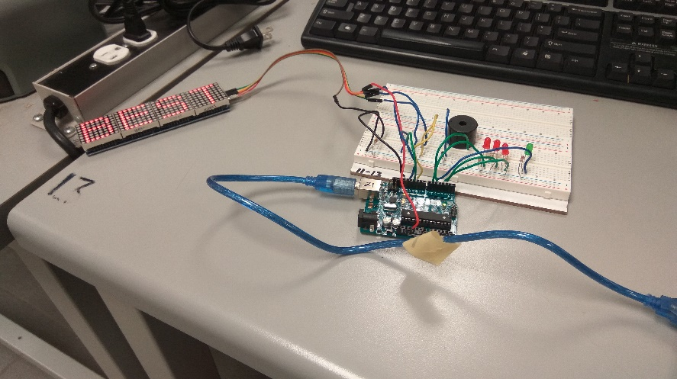

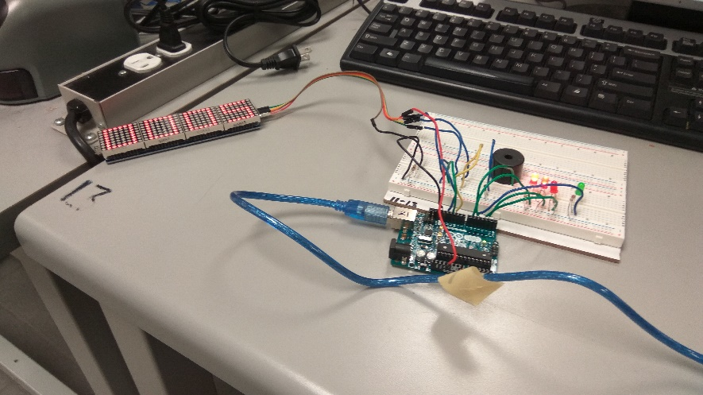

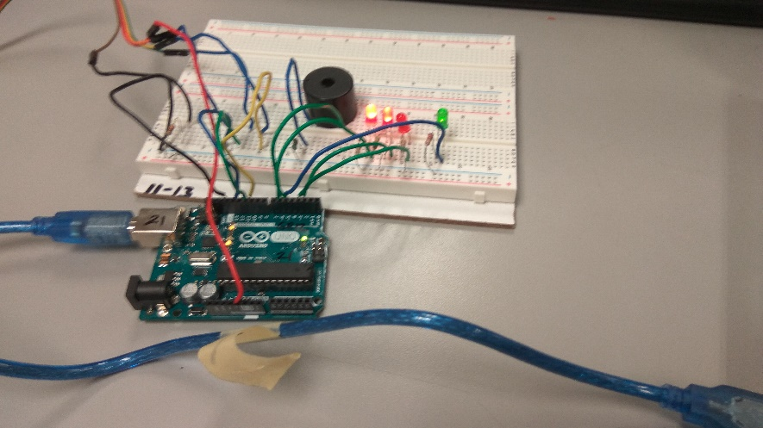

# Learn More

Check out these links to learn more!

* Processing API: <https://processing.org/reference/>
* Arduino API: <https://www.arduino.cc/reference/en/>
* Arduino LED Control Library (Matrix Controller): <https://playground.arduino.cc/Main/LedControl>
* Arduino Thread Library: <https://github.com/ivanseidel/ArduinoThread/blob/master/README.md>